**OPERATING SYSTEMS**

**Laboratory 4**

Name:Ujash

Surname:Patel

Index number: 36283

**Introduction**

* 10 points maximum.
* All commands must be executed in the Linux terminal. Don't use Linux GUI to solve the exercises.

**Exercise 1. (4 points)**

Create 3 password hashes with the **md5deep** program (save the results to the **hash.txt** file):

- 123

- abc

- abc10

*Paste the instructions:*

ls -l

echo “123”> hash.txt

echo “abc”>>hash.txt

echo “abc10”hash.txt

md5sum hash.txt

*Paste the screenshots of the completed task*

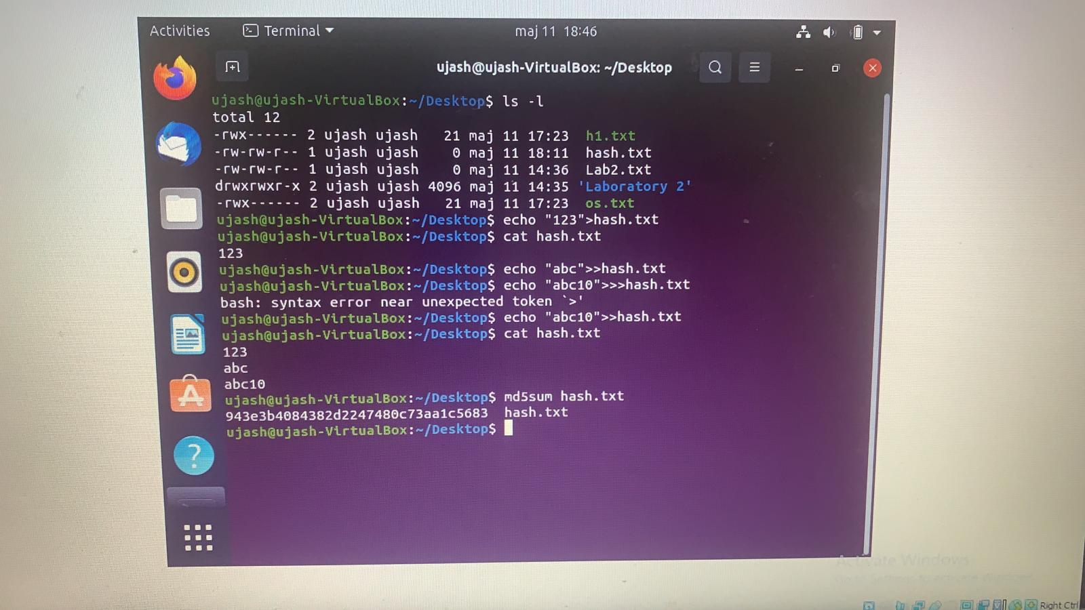

**Exercise 2. (6 points)**

Use the **hashcat** (sudo apt-get install hashcat) program to try to crack the above hashes. Use dictionary attack (rockyou.txt) and brute force attack.

*Paste the instructions:*

*Paste the screenshots of the completed task*